

Lab Policy and Rules:

1. 100% attendance is mandatory. In case of an emergency, you can avail yourself of up to 3 absences. So, don't waste your absences , save them for emergencies. If you are debarred from the course due to low attendance, do not come to me to correct it.

2. Disturbing the class environment during lab sessions. such as by talking, using mobile phones, eating, etc. will result in penalties (e.g., deduction of marks).

3. Lab tasks will not be accepted if you are absent. If you miss a lab, you cannot submit that lab task.

4. Lab demos for each lab task will be conducted at the end of each session. If you miss the demo for any reason, no retake will be allowed, and that lab will be marked as 0.

5. All quizzes will be unannounced. Be prepared for surprise quizzes. Quizzes will cover content from previous labs as well as theory lectures from the corresponding theory course.

6. Use of AI is strictly prohibited, anyone found using AI or copying code from fellow student will be marked 0 in the lab task . You should be able to explain the syntax or material used in your tasks.

7. Do not ask for personal favors. If you have concerns, such as short attendance, please speak to the relevant authority (e.g., academics).

8. Students on warning: Now is the time to study and earn a good grade. Do not ask for extra marks at the end if you are unable to clear your warning.

Lab#02 - Dynamic Memory Allocation

Learning Objectives:
- Understand and apply dynamic memory allocation using new and delete to manage memory for custom data structures like book records.
- Manipulate data structures using pointer notation to access and modify dynamically allocated memory efficiently.
- Implement memory-safe C++ programs that manage resources properly and prevent memory leaks through proper allocation and deallocation practices.

Outcomes:
- Create and manage dynamic arrays to store and update a growing set of book records at runtime.
- Write modular C++ functions that handle inventory operations (add, delete, search, update) using pointer-based data access.
- Analyze and debug memory-related issues, such as segmentation faults or memory leaks, ensuring proper resource cleanup upon program exit.

C++ Dynamic Memory
A good understanding of how dynamic memory really works in C++ is essential to becoming a good C++ programmer. Memory in your C++ program is divided into two parts.
- The stack All variables declared inside the function will take up memory from the stack.
- The heap This is unused memory of the program and can be used to allocate the memory dynamically when program runs.
Many times, you are not aware in advance how much memory you will need to store particular information in a defined variable, and the size of required memory can be determined at run time.
You can allocate memory at run time within the heap for the variable of a given type using a special operator in C++ which returns the address of the space allocated. This operator is called new operator.
If you are not in need of dynamically allocated memory anymore, you can use delete operator, which de-allocates memory that was previously allocated by new operator.
new and delete operators in C++ for dynamic memory.
Dynamic memory allocation in C/C++ refers to performing memory allocation manually by programmer. Dynamically allocated memory is allocated on Heap and non-static and local variables get memory allocated on Stack (Refer Memory Layout C Programs for details).

What are applications?
- One use of dynamically allocated memory is to allocate memory of variable size which is not possible with compiler allocated memory except variable length arrays.
- The most important use is flexibility provided to programmers. We are free to allocate and deallocate memory whenever we need and whenever we don’t need anymore. There are many cases where this flexibility helps. Examples of such cases are Linked List, Tree, etc.

How is it different from memory allocated to normal variables?
For normal variables like “int a”, “char str [10]”, etc, memory is automatically allocated and deallocated. For dynamically allocated memory like “int *p = new int [10]”, it is programmers’ responsibility to deallocate memory when no longer needed. If programmer doesn’t deallocate memory, it causes memory leak (memory is not deallocated until program terminates).

How is memory allocated/deallocated in C++?
C uses malloc () and calloc() function to allocate memory dynamically at run time and uses free () function to free dynamically allocated memory. C++ supports these functions and has two operators new and delete that perform the task of allocating and freeing the memory in a better and easier way.
This is all about new and delete operators.
new operator
The new operator denotes a request for memory allocation on the Free Store. If sufficient memory is available, new operator initializes the memory and returns the address of the newly allocated and initialized memory to the pointer variable.
- Syntax to use new operator: To allocate memory of any data type, the syntax is: pointer-variable = new datatype.
- Here, pointer-variable is the pointer of type datatype. Datatype could be any built-in data type including array or any user defined data types including structure and class.
Example:
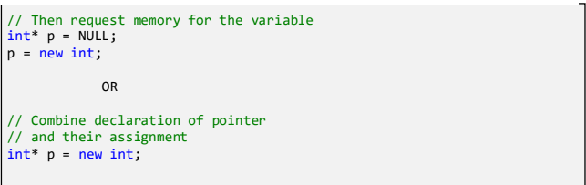

Initialize memory:
We can also initialize the memory for built-in data types using new operator. For custom data types a constructor is required (with the datatype as input) for initializing the value. Here’s an example for the initialization of both data types: pointer-variable = new datatype(value);
Example 1
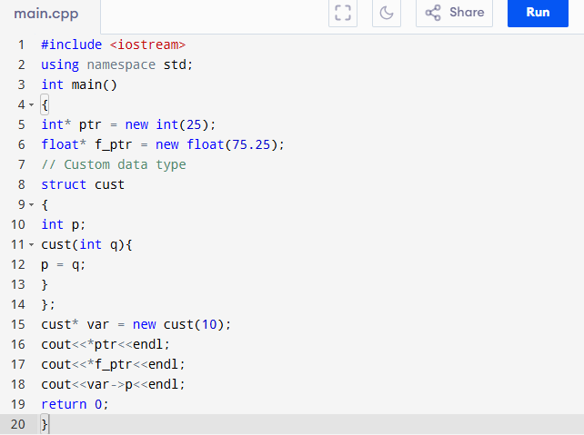
- Allocate block of memory: new operator is also used to allocate a block (an array) of memory of type datatype. pointer-variable = new datatype[size];
- where size (a variable) specifies the number of elements in an array. Example: int *p = new int [10]
- Dynamically allocates memory for 10 integers continuously of type int and returns pointer to the first element of the sequence, which is assigned to p (a pointer). p [0] refers to first element, p [1] refers to second element and so on.
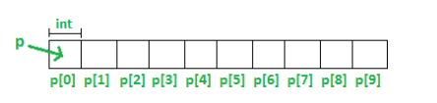

Normal Array Declaration vs Using new
There is a difference between declaring a normal array and allocating a block of memory using new. The most important difference is, normal arrays are deallocated by compiler (If array is local, then deallocated when function returns or completes). However, dynamically allocated arrays always remain there until either they are deallocated by programmer or program terminates.

What if enough memory is not available during runtime?
If enough memory is not available in the heap to allocate, the new request indicates failure by throwing an exception of type std::bad_alloc, unless “nothrow” is used with the new operator, in which case it returns a NULL pointer (scroll to section “Exception handling of new operator” in this article). Therefore, it may be good idea to check for the pointer variable produced by new before using it program.
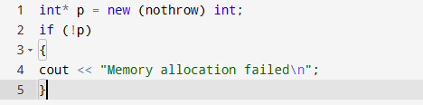

Delete operator
Since it is programmer’s responsibility to deallocate dynamically allocated memory, programmers are provided delete operator by C++ language.
Syntax:
// Release memory pointed by pointer-variable
delete pointer-variable.
Here, pointer-variable is the pointer that points to the data object created by new.
Examples:
delete p;
delete q;
To free the dynamically allocated array pointed by pointer-variable, use following form of delete:
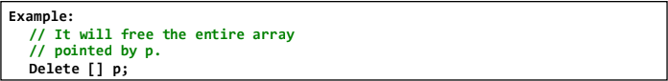
Example 2
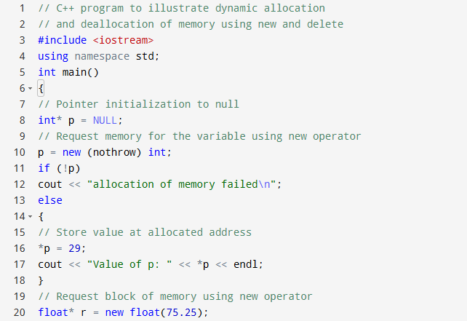
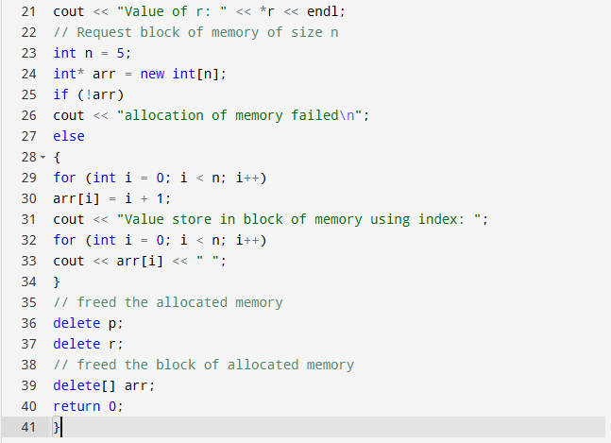
Output:
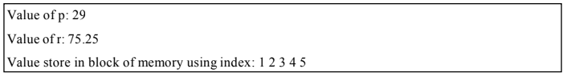

Dynamic Memory Allocation for Objects
Objects are no different from simple data types. For example, consider the following code where we are going to use an array of objects to clarify the concept.
Example 3
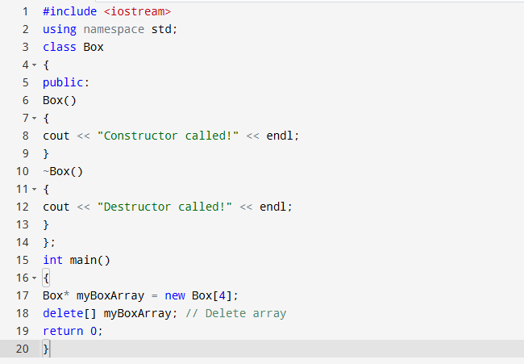
If you were to allocate an array of four Box objects, the Simple constructor would be called four times and similarly while deleting these objects, destructor will also be called same number of times. If we compile and run above code, this will produce the following result.
Constructor called!
Constructor called!
Constructor called!
Constructor called!
Destructor called!
Destructor called!
Destructor called!
Destructor called!

Dynamic memory allocation in C++ for 1D and 2D
This post will discuss dynamic memory allocation in C++ for multidimensional arrays.

1. Single Dimensional Array
Example 4
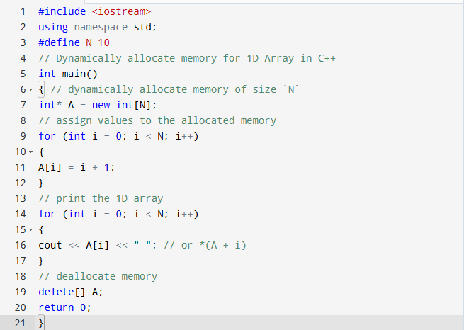

2. 2-Dimensional Array
In C/C++, multidimensional arrays in simple words as an array of arrays. Data in multidimensional arrays are stored in tabular form (in row major order).
Below is the diagrammatic representation of 2D arrays:
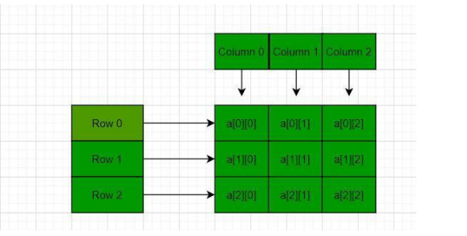

Using array of Pointers
We can dynamically create an array of pointers of size M and then dynamically allocate memory of size N for each row, as shown below:
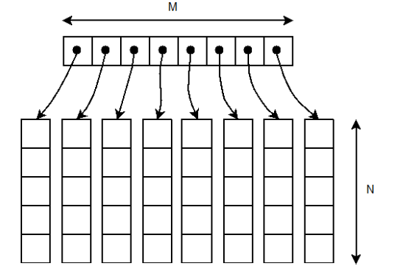
Example 5
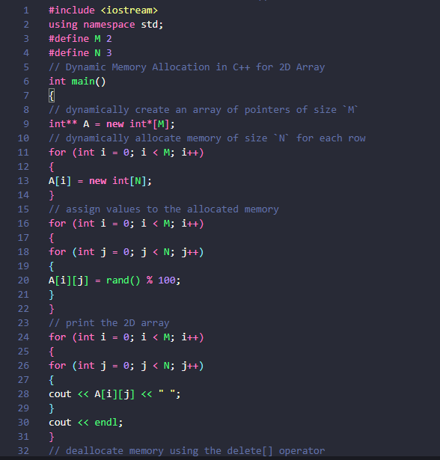
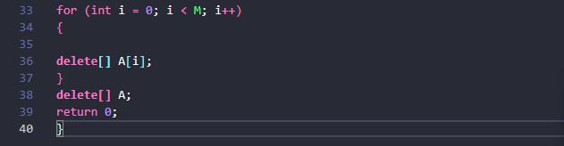

Lab Task
You're tasked with creating a C++ program for a bookstore that dynamically manages its inventory. The program should allow the user to perform various operations using pointer notation:
- Add Book to Inventory:
- Implement a function to add a new book to the inventory. Prompt the user to input the book's title, author, and quantity. Utilize dynamic memory allocation to store the book information efficiently.
- Sell Book:
- Develop a function to sell a book from the inventory. Prompt the user to input the title of the book they wish to purchase and update the inventory accordingly.
- Find Book by Author:
- Write a function to search for books by a specific author. Prompt the user to input the author's name and display all books written by that author.
- Display Inventory:
- Create a function to display the current inventory, including the title, author, and quantity of each book.
- Update Book Quantity:
- Implement a function to update the quantity of a book in the inventory. Prompt the user to input the title of the book and the new quantity.
- Delete Book from Inventory:
- Provide functionality to remove a book from the inventory. Prompt the user to input the book's unique identifier and confirm the deletion.
- Sales Reporting:
- Implement a feature to generate sales reports for a specified time period. Calculate total sales revenue and display top-selling books based on sales volume.
- Exit Program:
- Provide an option to exit the program gracefully. Implement efficient memory management techniques to prevent memory leaks and optimize resource usage.
Ensure error handling for invalid inputs and dynamic memory management for the inventory. Your program should provide an efficient and user-friendly interface for managing the bookstore's inventory dynamically.

Rubrics
Criteria | Marks | Evaluation Notes
1. Functionality Implementation | 4 marks
a. Basic operations (Add, Sell, Display) | 2 | All work and update inventory correctly using pointer notation.
b. Advanced features (Search, Update, Delete, Reporting) | 2 | Each additional feature functions properly, including valid input handling.
2. Dynamic Memory Management | 2 marks
a. Correct use of new and delete | 1 | Dynamically allocated memory is used for book structures.
b. No memory leaks (validated via valgrind or similar) | 1 | Memory is freed appropriately when books are deleted or program exits.
3. Pointer Notation Usage | 1 mark | Efficient use of pointer notation instead of array notation (e.g., *(ptr + i) instead of arr[i]).
4. Error Handling & Input Validation | 1 mark | Handles invalid titles, quantities, and operations gracefully without crashing.
5. User Interface & Interaction Design | 1 mark | Clear prompts, menu-based interface, readable output. Easy for users to understand and interact with.
6. Code Quality & Documentation | 1 mark | Code is clean, modular (functions used), meaningful variable names, and includes comments where appropriate.

Task Submission Guidelines:
- Make a document and paste all tasks solution there (Not screenshot) and save it as pdf.
- Along with each task solution, also upload the screenshot of the output.
- Include your name and roll no. at the front page.
- Please submit your file in this format (Roll_number-name) i.e (24I-1234-Ali.pdf).
- Files other than pdf will not be accepted and will be marked as 0.

